Abraham Rescues Lot

Lots’ wife was turned into a pillar of salt because she turned back to Sodom and did not turn to God. Make a poster using salt, to remind us of the story.
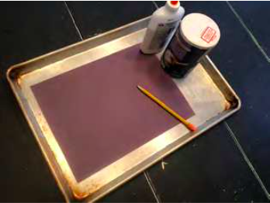
You will need:
- Black or dark coloured paper
- Baking Sheet
- Pencils
- Glue
- Table Salt

Instructions:
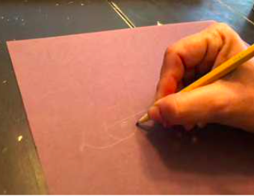
- On the paper use your pencils to write, “Do not turn back,
1.
turn to God.”
- Go over the pencil letters with glue.
- Shake the salt onto the glue words, making sure the salt coves the letters completely. You might want to place a baking sheet under the paper, to catch the excess salt.
- Shake of the excess salt and allow the glue to dry.
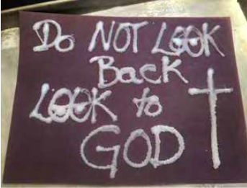
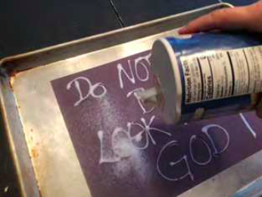
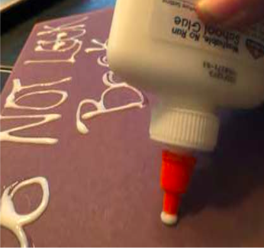
- Display your poster, to remind you of the story of Lot’s wife.
5.
3 & 4
2.

